SIMATS ENGINEERING (SAVEETHA SCHOOL OF ENGINEERING)
Department of Computer Science and Engineering
CO3 ASSESSMENT TOOL 2 – Code Review & Repository Evaluation

Course Code: | CSA10 / CSA1007 | Course Title: | Software Engineering
CO Assessed: | CO3 | Assessment: | Assessment Tool 1 – Intelligent Nuclear Power Plant Monitoring Platform
Weightage: | 20% | Total Marks: | 25
CO3 Statement: | Build full-stack applications with an emphasis on containerization, version control, and collaborative development
Student Name: | V.Naga Revanth | Reg. No.: | 192411128
Date: |  | Duration: | 60 minutes

Code of Conduct
I _______V.Naga Revanth /192411128___________________ (Name / Reg No) certify that this submission is my original work and that I have adhered to the guidelines specified for this assessment. I understand that any violation of academic integrity rules will result in disciplinary action.
Signature of the Student: _________________________
Annexure A – Intelligent Nuclear Power Plant Monitoring Platform

1. Problem Overview
1.1 Problem Statement
The Intelligent Nuclear Power Plant Monitoring Platform is a software-based monitoring and decision-support system designed to continuously observe reactor conditions, equipment health, radiation levels, and operational parameters.
Traditional monitoring may involve multiple independent systems and significant manual observation. This can make it difficult to analyze large amounts of sensor data, identify abnormal patterns quickly, predict equipment failures, and generate consolidated compliance information.
The proposed platform integrates sensor data collection, real-time monitoring, anomaly detection, predictive maintenance, alert management, dashboards, and reporting into one software platform.
Note: The platform is designed as a monitoring and decision-support application. It does not directly control safety-critical reactor systems.

1.2 Project Objectives
The main objectives are:
- Monitor reactor conditions continuously.
- Monitor radiation levels.
- Detect abnormal operating conditions.
- Predict potential equipment failures.
- Generate alerts for authorized personnel.
- Provide real-time dashboards.
- Store historical sensor information.
- Generate maintenance and compliance reports.
- Maintain secure user access.
- Improve decision support and reduce unplanned downtime.

1.3 Key Functionalities
The implemented/project solution consists of the following major functions:
- User authentication.
- Role-based access.
- Real-time monitoring dashboard.
- Sensor data collection.
- Radiation monitoring.
- Equipment health monitoring.
- Anomaly detection.
- Predictive maintenance.
- Alert management.
- Historical data analysis.
- Report generation.
- Audit logging.
- Database management.

2. Repository Organization
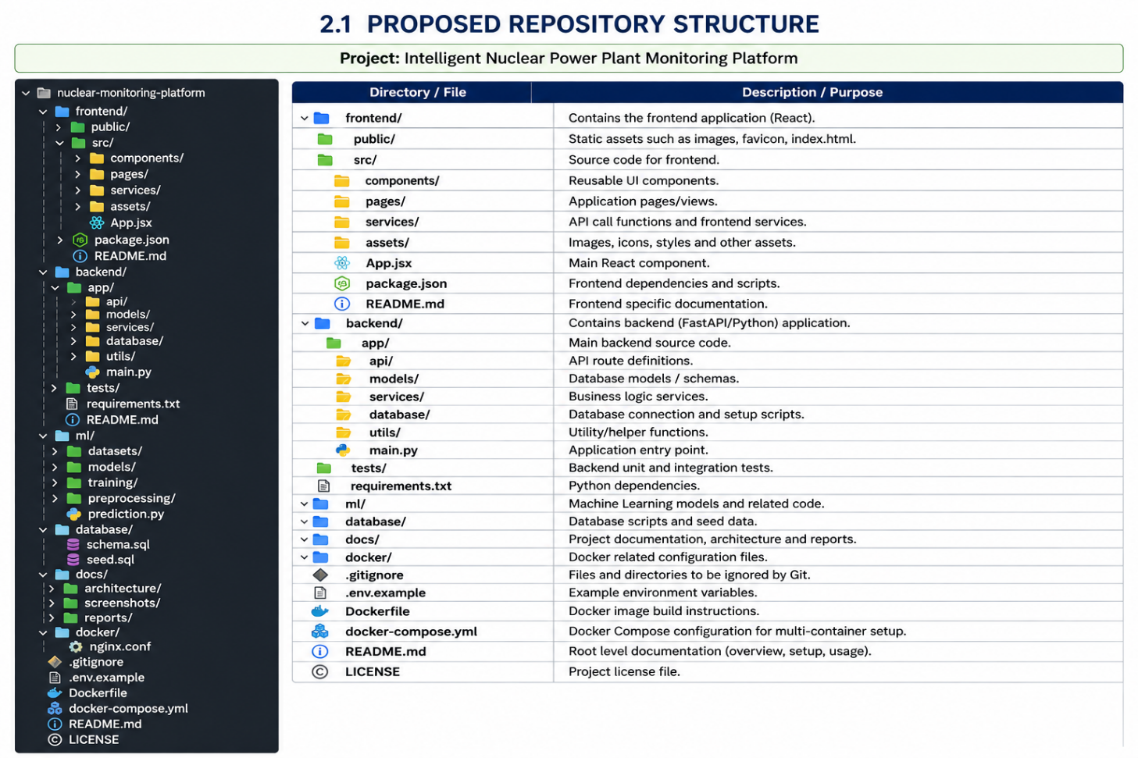
2.1 Proposed Repository Structure

2.2 Folder Evaluation
Folder/File | Purpose | Evaluation
frontend/ | User interface | Well separated
backend/ | APIs and business logic | Modular
ml/ | AI/ML functionality | Separates analytics
database/ | Database scripts | Organized
docs/ | Project documentation | Easy to maintain
tests/ | Test cases | Supports validation
Dockerfile | Containerization | Supports deployment
docker-compose.yml | Multi-service deployment | Simplifies execution
.gitignore | Prevents unnecessary files | Good practice
README.md | Project documentation | Essential
.env.example | Environment configuration example | Improves setup

2.3 Repository Organization Evaluation
The repository follows separation of concerns. Frontend, backend, machine-learning components, database scripts, tests, and documentation are maintained separately.
This organization improves:
- Maintainability
- Collaboration
- Code navigation
- Testing
- Deployment
- Version control
- Future development
For example, a developer working on the dashboard can modify the frontend/ directory without unnecessarily changing backend or ML components.

3. Code Quality Review
3.1 Readability
The source code should use meaningful variable, function, class, and file names.
Good Example
def get_radiation_readings():
readings = sensor_repository.get_radiation_data()
return readings
The function name clearly explains its purpose.
Poor Example
def fun1():
x = db.get()
return x
The second example does not clearly communicate the purpose of the function.
Recommendation
Use descriptive names such as:
get_radiation_readings()
calculate_equipment_health()
generate_alert()
predict_equipment_failure()
generate_compliance_report()

4. Modularity Review
The project should divide functionality into independent modules.
Backend
│
├── Authentication
├── Monitoring
├── Radiation
├── Anomaly Detection
├── Predictive Maintenance
├── Alerts
└── Reporting
Each module should have one major responsibility.
Example
class AlertService:

def generate_alert(self, condition):
if condition == "critical":
return "Critical alert generated"
The alert functionality is separated from monitoring and reporting.
Evaluation
Strength: Modular design improves maintainability.
Improvement: Avoid placing database queries, business logic, and user-interface logic in the same file.

5. Coding Standards
The following coding practices should be followed:
- Use meaningful names.
- Follow consistent indentation.
- Avoid unnecessary duplicate code.
- Use comments for complex logic.
- Keep functions reasonably small.
- Use exception handling.
- Validate user input.
- Separate configuration from source code.
- Follow language-specific coding standards.
Example
Instead of:
if temp > 100:
print("Alert")
use a named constant:
MAX_SAFE_TEMPERATURE = 100

if temperature > MAX_SAFE_TEMPERATURE:
generate_alert()
This improves readability and maintainability.

6. Documentation Review
6.1 Code Documentation
Important functions should contain documentation.
def calculate_health_score(sensor_data):
"""
Calculates the equipment health score
using validated sensor measurements.
"""
# Processing logic
Documentation helps future developers understand the purpose of the code.

7. Code Quality Strengths
The proposed project demonstrates several good software engineering practices:
1. Modularity
Separate services can handle monitoring, alerts, analytics, and reporting.
2. Separation of Concerns
Frontend, backend, database, and ML components are separated.
3. Reusability
Common services such as authentication and database access can be reused.
4. Maintainability
Changes can be made to individual modules without redesigning the entire application.
5. Scalability
Additional services and sensors can be incorporated later.
6. Security
Role-based access and authentication can restrict access to sensitive information.

8. Areas for Improvement
Area | Current Issue | Recommended Improvement
Code duplication | Similar logic may occur in multiple modules | Create reusable functions
Error handling | Unexpected errors may affect services | Add structured exception handling
Testing | More automated tests needed | Add unit and integration tests
Security | Configuration may contain sensitive values | Use environment variables/secrets
Documentation | Some functions may lack descriptions | Add docstrings
Logging | Basic console logging | Use centralized structured logging
Validation | Sensor/user input may be incomplete | Add validation layer
Dependency management | Versions may change | Pin dependency versions

9. Version Control Evaluation
9.1 Git Repository
Git is used to track source-code changes and support collaborative development.
The repository should contain:
main
│
└── development
│
├── feature/dashboard
├── feature/authentication
├── feature/radiation
├── feature/alerts
└── feature/predictive-maintenance

10. Branching Strategy Evaluation
Main Branch
Contains stable and tested code.
Development Branch
Contains integrated development work.
Feature Branches
Used for individual functionality.
Examples:
feature/dashboard
feature/radiation-monitoring
feature/alert-system
feature/predictive-maintenance
Hotfix Branch
Used to correct urgent problems in the stable version.
Evaluation
This branching strategy is appropriate because multiple developers can work independently without modifying the stable branch directly.

11. Commit History Evaluation
Example professional commit history:
a81f2d1 feat: add user authentication
b71d4c2 feat: implement sensor data API
c61e3a8 feat: create monitoring dashboard
d51a9f7 feat: add radiation monitoring
e41b7c6 feat: implement anomaly detection
f31c2d5 feat: add alert notification service
g21d4a3 test: add monitoring service tests
h11e5b2 docs: update installation guide
i01e4c9 chore: add Docker configuration
Commit Message Evaluation
The messages use prefixes such as:
feat:
fix:
test:
docs:
chore:
This makes the history easier to understand.
Recommended Practice
Avoid messages such as:
update
changes
final
new code
done
Prefer:
feat: add radiation monitoring dashboard
fix: handle missing sensor readings
test: add anomaly detection tests
docs: update Docker deployment guide

12. Version Control Benefits
Git supports:
- Collaboration
- Version tracking
- Branch-based development
- Code review
- Rollback
- Conflict resolution
- Release management
- Change traceability
For a large monitoring platform, maintaining a clear history is especially important because developers need to know what changed, when it changed, and why it changed.

13. Code Testing and Validation
Testing is required to verify that the system performs according to its requirements.
13.1 Test Case Table
Test ID | Test Case | Input | Expected Result
TC01 | User Login | Valid credentials | Dashboard opens
TC02 | Invalid Login | Wrong password | Error displayed
TC03 | Sensor Data | Valid sensor reading | Data stored
TC04 | Radiation Monitoring | Normal reading | Normal status
TC05 | Radiation Alert | Abnormal reading | Alert generated
TC06 | Equipment Prediction | Historical data | Prediction displayed
TC07 | Dashboard | User login | Current plant status displayed
TC08 | Report Generation | Date range | Report generated
TC09 | Unauthorized Access | Restricted page | Access denied
TC10 | Database Failure | Database unavailable | Error/fallback handled

14. Example Test Case: User Authentication
Test ID
TC01
Objective
Verify that an authorized user can log into the platform.
Input
Username: operator01
Password: ********
Expected Result
Login successful
↓
Role verified
↓
Operator Dashboard displayed
Status
PASS

15. Example Test Case: Radiation Monitoring
Test ID
TC05
Objective
Verify that the system generates an alert when an abnormal radiation condition is detected.
Input
Radiation Sensor
↓
Abnormal Reading
Expected Result
Sensor Data
↓
Anomaly Detection
↓
Critical Condition
↓
Alert Service
↓
Safety Dashboard
Status
PASS

16. Testing Levels
Unit Testing
Tests individual functions.
Example:
calculate_health_score()
generate_alert()
validate_sensor_data()
Integration Testing
Tests communication between components.
Example:
Sensor API → Backend → Database
System Testing
Tests the complete application.
Login → Dashboard → Monitoring → Alert → Report
Security Testing
Tests:
- Unauthorized login.
- Invalid tokens.
- Role restrictions.
- API access.
- Input validation.
Performance Testing
Tests the system under increasing numbers of sensor readings and users.

17. Repository Documentation Evaluation
The project should contain a comprehensive README.md.
Recommended README Structure
# Intelligent Nuclear Power Plant Monitoring Platform

## Project Overview

## Features

## Architecture

## Technologies Used

## System Requirements

## Installation

## Environment Configuration

## Database Setup

## Running the Application

## Docker Deployment

## Testing

## API Documentation

## Screenshots

## Project Structure

## Contributors

## License

18. Installation Guide
The README should provide clear instructions.
Step 1: Clone Repository
git clone <repository-url>
cd nuclear-monitoring-platform
Step 2: Install Dependencies
pip install -r backend/requirements.txt
Step 3: Configure Environment
DATABASE_URL=your_database_url
SECRET_KEY=your_secret_key
Step 4: Start Backend
uvicorn app.main:app --reload
Step 5: Start Frontend
npm install
npm run dev
Docker Method
docker compose build
docker compose up -d

19. Repository Maintenance Evaluation
The repository should be maintained using the following practices:
- Regular commits.
- Feature branches.
- Pull requests.
- Code reviews.
- Automated tests.
- Dependency updates.
- Issue tracking.
- Release tags.
- Documentation updates.
- Removal of unused files.
Example:
v1.0.0
↓
Initial monitoring platform

v1.1.0
↓
Radiation monitoring

v1.2.0
↓
Predictive maintenance

v2.0.0
↓
Advanced analytics

20. Code Review Findings
Positive Findings
- Project structure is modular.
- Frontend and backend are separated.
- Database components are organized.
- Git supports version control.
- Docker supports portable deployment.
- Separate services improve maintainability.
- Testing can be integrated into the repository.
- Documentation structure supports collaboration.
Identified Issues
- More automated tests are required.
- Code duplication should be reduced.
- Error handling should be standardized.
- API security should be strengthened.
- Dependency versions should be controlled.
- README documentation should be kept updated.
- Logging should be centralized.
- Environment variables should not contain hard-coded secrets.

21. Recommendations
Code Quality
- Follow consistent coding standards.
- Use meaningful names.
- Apply modular design.
- Avoid duplicate code.
- Add code comments where necessary.
Testing
- Increase unit-test coverage.
- Add integration tests.
- Add API tests.
- Automate regression testing.
Git
- Use feature branches.
- Use descriptive commit messages.
- Perform pull-request reviews.
- Protect the main branch.
- Tag stable releases.
Security
- Never commit passwords or API keys.
- Use environment variables/secrets.
- Implement RBAC.
- Validate all inputs.
- Secure API endpoints.
- Maintain audit logs.
Documentation
- Maintain a complete README.
- Add architecture diagrams.
- Document APIs.
- Add installation instructions.
- Include troubleshooting information.

22. Future Enhancements
The project can be improved by adding:
- Advanced AI-based predictive maintenance.
- Digital Twin integration.
- Real-time mobile notifications.
- Automated CI/CD pipelines.
- Cloud-based analytics.
- Advanced system monitoring.
- Automated test pipelines.
- Explainable AI for predictions.
- Multi-plant monitoring.
- Improved visualization and reporting.

23. Overall Code Review Score
Evaluation Area | Assessment | Suggested Score
Problem Analysis & Repository Organization | Clear modular organization | 4/4
Code Quality Review | Good modularity with areas for improvement | 4/4
Version Control Evaluation | Structured branching and meaningful commits | 4/4
Testing & Validation | Functional and automated testing can be expanded | 3/4
Documentation & Repository Maintenance | Good structure; documentation should be continuously updated | 4/4
Findings, Recommendations & Presentation | Clear recommendations and professional organization | 4/4
Overall Assessment: Excellent / Very Good

24. Screenshots to Include in Your Report
For the final submission, add your actual screenshots at the following locations:
Screenshot 1 – Repository Structure
[INSERT SCREENSHOT OF GITHUB/GIT REPOSITORY HERE]
Screenshot 2 – Git Branches
[INSERT SCREENSHOT OF git branch HERE]
Screenshot 3 – Commit History
[INSERT SCREENSHOT OF git log --oneline HERE]
Screenshot 4 – Source Code
[INSERT SCREENSHOT OF CODE IN VS CODE HERE]
Screenshot 5 – Application Dashboard
[INSERT SCREENSHOT OF MONITORING DASHBOARD HERE]
Screenshot 6 – Test Execution
[INSERT SCREENSHOT OF TEST RESULTS HERE]
Screenshot 7 – Docker Containers
[INSERT SCREENSHOT OF docker compose ps HERE]
Screenshot 8 – Running Application
[INSERT SCREENSHOT OF BROWSER APPLICATION HERE]

25. Conclusion
The Intelligent Nuclear Power Plant Monitoring Platform demonstrates how software engineering practices can be applied to develop a maintainable and scalable monitoring solution. The repository is organized into separate frontend, backend, database, machine-learning, testing, and documentation components.
The code review identifies modularity, separation of concerns, maintainability, Git-based version control, and Docker-based deployment as major strengths. Further improvements in automated testing, security, documentation, error handling, and CI/CD can improve the overall quality of the project.
The evaluation demonstrates that proper repository management, clean coding practices, systematic testing, meaningful Git commits, and complete documentation contribute significantly to the long-term maintainability and reliability of the software system

